CEEDS_ValidatedHistoricalData Document contextual model

Overview of the model

!# shows the model.
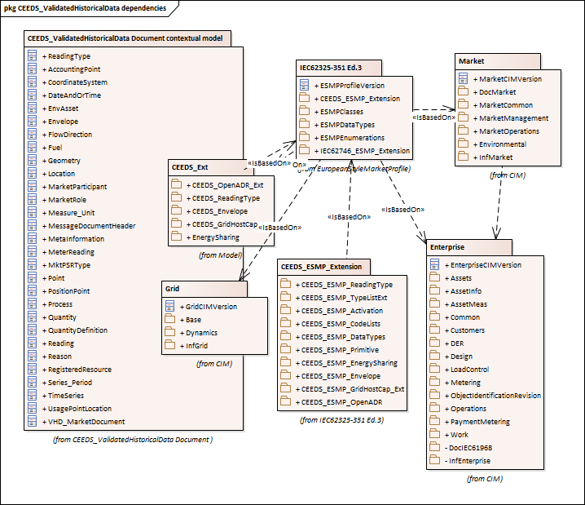

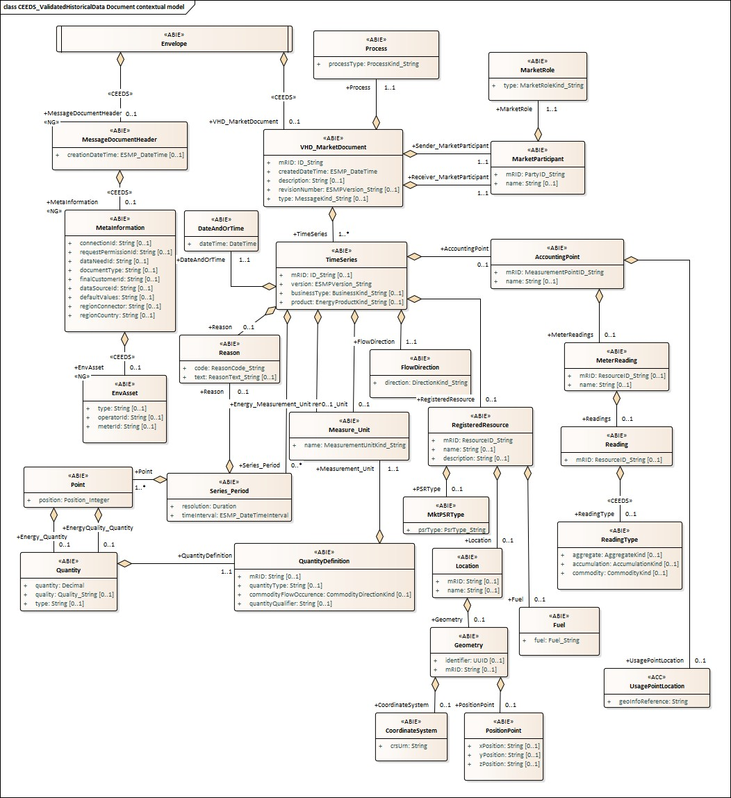

Figure !# - CEEDS_ValidatedHistoricalData Document contextual model

IsBasedOn relationships from the European style market profile

!# shows the traceability dependency of the classes used in this package towards the upper level. Table !# - IsBasedOn dependency

Name Complete IsBasedOn Path
AccountingPoint CIMProfiles::MarketProfiles::RD_Projects::CEEDS::CEEDS_ValidatedHistoricalData Document ::CEEDS_ValidatedHistoricalData Document contextual model::AccountingPoint

CoordinateSystem CIMProfiles::MarketProfiles::RD_Projects::CEEDS::CEEDS_ValidatedHistoricalData Document ::CEEDS_ValidatedHistoricalData Document contextual model::CoordinateSystem

DateAndOrTime CIMProfiles::MarketProfiles::RD_Projects::CEEDS::CEEDS_ValidatedHistoricalData Document ::CEEDS_ValidatedHistoricalData Document contextual model::DateAndOrTime

EnvAsset CIMProfiles::MarketProfiles::RD_Projects::CEEDS::CEEDS_ValidatedHistoricalData Document ::CEEDS_ValidatedHistoricalData Document contextual model::EnvAsset

Envelope CIMProfiles::MarketProfiles::RD_Projects::CEEDS::CEEDS_ValidatedHistoricalData Document ::CEEDS_ValidatedHistoricalData Document contextual model::Envelope

FlowDirection CIMProfiles::MarketProfiles::RD_Projects::CEEDS::CEEDS_ValidatedHistoricalData Document ::CEEDS_ValidatedHistoricalData Document contextual model::FlowDirection

Fuel CIMProfiles::MarketProfiles::RD_Projects::CEEDS::CEEDS_ValidatedHistoricalData Document ::CEEDS_ValidatedHistoricalData Document contextual model::Fuel

Geometry CIMProfiles::MarketProfiles::RD_Projects::CEEDS::CEEDS_ValidatedHistoricalData Document ::CEEDS_ValidatedHistoricalData Document contextual model::Geometry

Location CIMProfiles::MarketProfiles::RD_Projects::CEEDS::CEEDS_ValidatedHistoricalData Document ::CEEDS_ValidatedHistoricalData Document contextual model::Location

MarketParticipant CIMProfiles::MarketProfiles::RD_Projects::CEEDS::CEEDS_ValidatedHistoricalData Document ::CEEDS_ValidatedHistoricalData Document contextual model::MarketParticipant

MarketRole CIMProfiles::MarketProfiles::RD_Projects::CEEDS::CEEDS_ValidatedHistoricalData Document ::CEEDS_ValidatedHistoricalData Document contextual model::MarketRole

Measure_Unit CIMProfiles::MarketProfiles::RD_Projects::CEEDS::CEEDS_ValidatedHistoricalData Document ::CEEDS_ValidatedHistoricalData Document contextual model::Measure_Unit

MessageDocumentHeader CIMProfiles::MarketProfiles::RD_Projects::CEEDS::CEEDS_ValidatedHistoricalData Document ::CEEDS_ValidatedHistoricalData Document contextual model::MessageDocumentHeader

MetaInformation CIMProfiles::MarketProfiles::RD_Projects::CEEDS::CEEDS_ValidatedHistoricalData Document ::CEEDS_ValidatedHistoricalData Document contextual model::MetaInformation

MeterReading CIMProfiles::MarketProfiles::RD_Projects::CEEDS::CEEDS_ValidatedHistoricalData Document ::CEEDS_ValidatedHistoricalData Document contextual model::MeterReading

MktPSRType CIMProfiles::MarketProfiles::RD_Projects::CEEDS::CEEDS_ValidatedHistoricalData Document ::CEEDS_ValidatedHistoricalData Document contextual model::MktPSRType

Point CIMProfiles::MarketProfiles::RD_Projects::CEEDS::CEEDS_ValidatedHistoricalData Document ::CEEDS_ValidatedHistoricalData Document contextual model::Point

PositionPoint CIMProfiles::MarketProfiles::RD_Projects::CEEDS::CEEDS_ValidatedHistoricalData Document ::CEEDS_ValidatedHistoricalData Document contextual model::PositionPoint

Process CIMProfiles::MarketProfiles::RD_Projects::CEEDS::CEEDS_ValidatedHistoricalData Document ::CEEDS_ValidatedHistoricalData Document contextual model::Process

Quantity CIMProfiles::MarketProfiles::RD_Projects::CEEDS::CEEDS_ValidatedHistoricalData Document ::CEEDS_ValidatedHistoricalData Document contextual model::Quantity

QuantityDefinition CIMProfiles::MarketProfiles::RD_Projects::CEEDS::CEEDS_ValidatedHistoricalData Document ::CEEDS_ValidatedHistoricalData Document contextual model::QuantityDefinition

Reading CIMProfiles::MarketProfiles::RD_Projects::CEEDS::CEEDS_ValidatedHistoricalData Document ::CEEDS_ValidatedHistoricalData Document contextual model::Reading

ReadingType CIMProfiles::MarketProfiles::RD_Projects::CEEDS::CEEDS_ValidatedHistoricalData Document ::CEEDS_ValidatedHistoricalData Document contextual model::ReadingType

Reason CIMProfiles::MarketProfiles::RD_Projects::CEEDS::CEEDS_ValidatedHistoricalData Document ::CEEDS_ValidatedHistoricalData Document contextual model::Reason

RegisteredResource CIMProfiles::MarketProfiles::RD_Projects::CEEDS::CEEDS_ValidatedHistoricalData Document ::CEEDS_ValidatedHistoricalData Document contextual model::RegisteredResource

Series_Period CIMProfiles::MarketProfiles::RD_Projects::CEEDS::CEEDS_ValidatedHistoricalData

Document ::CEEDS_ValidatedHistoricalData Document contextual model::Series_Period

TimeSeries CIMProfiles::MarketProfiles::RD_Projects::CEEDS::CEEDS_ValidatedHistoricalData Document ::CEEDS_ValidatedHistoricalData Document contextual model::TimeSeries

UsagePointLocation CIMProfiles::MarketProfiles::RD_Projects::CEEDS::CEEDS_ValidatedHistoricalData Document ::CEEDS_ValidatedHistoricalData Document contextual model::UsagePointLocation

VHD_MarketDocument CIMProfiles::MarketProfiles::RD_Projects::CEEDS::CEEDS_ValidatedHistoricalData Document ::CEEDS_ValidatedHistoricalData Document contextual model::VHD_MarketDocument

##MXM##

CEEDS_ValidatedHistoricalData Document assembly model

Overview of the model

!# shows the model.
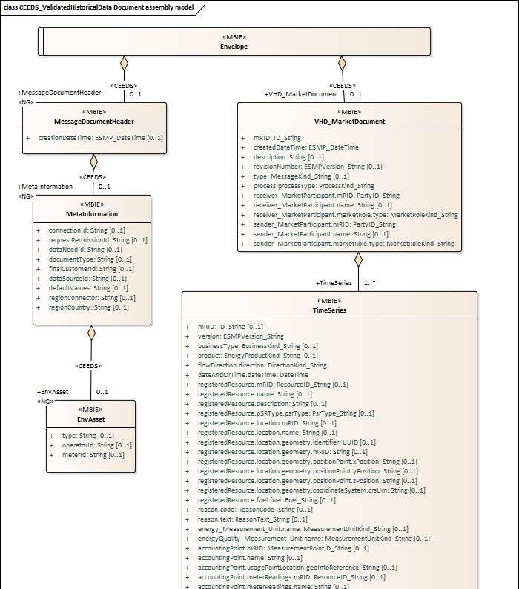

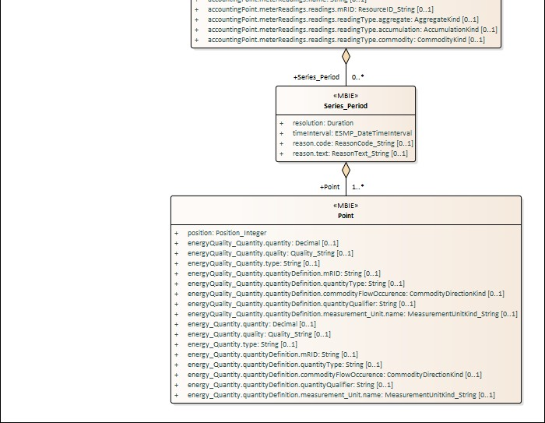

Figure !# - CEEDS_ValidatedHistoricalData Document assembly model

IsBasedOn relationships from the European style market profile

!# shows the traceability dependency of the classes used in this package towards the upper level. Table !# - IsBasedOn dependency

Name Complete IsBasedOn Path

EnvAsset CIMProfiles::MarketProfiles::RD_Projects::CEEDS::CEEDS_ValidatedHistoricalData Document ::CEEDS_ValidatedHistoricalData Document assembly model::EnvAsset

Envelope CIMProfiles::MarketProfiles::RD_Projects::CEEDS::CEEDS_ValidatedHistoricalData Document ::CEEDS_ValidatedHistoricalData Document assembly model::Envelope

MessageDocumentHeader CIMProfiles::MarketProfiles::RD_Projects::CEEDS::CEEDS_ValidatedHistoricalData Document ::CEEDS_ValidatedHistoricalData Document assembly model::MessageDocumentHeader

MetaInformation CIMProfiles::MarketProfiles::RD_Projects::CEEDS::CEEDS_ValidatedHistoricalData Document ::CEEDS_ValidatedHistoricalData Document assembly model::MetaInformation

Point CIMProfiles::MarketProfiles::RD_Projects::CEEDS::CEEDS_ValidatedHistoricalData Document ::CEEDS_ValidatedHistoricalData Document assembly model::Point

Series_Period CIMProfiles::MarketProfiles::RD_Projects::CEEDS::CEEDS_ValidatedHistoricalData Document ::CEEDS_ValidatedHistoricalData Document assembly model::Series_Period

TimeSeries CIMProfiles::MarketProfiles::RD_Projects::CEEDS::CEEDS_ValidatedHistoricalData Document ::CEEDS_ValidatedHistoricalData Document assembly model::TimeSeries

VHD_MarketDocument CIMProfiles::MarketProfiles::RD_Projects::CEEDS::CEEDS_ValidatedHistoricalData Document ::CEEDS_ValidatedHistoricalData Document assembly model::VHD_MarketDocument

##MXM##

Detailed CEEDS_ValidatedHistoricalData Document assembly model

Envelope root class

The envelope entity is a non-CIM object used in an energy data space environment to serve as a central top- level entity connecting the MarketDocumentHeader (energy data space specific context information block) with the regular CIM MarketDocument.

!# shows all association ends of Envelope with other classes.

Table !# - Association ends of CEEDS_ValidatedHistoricalData Document assembly model::Envelope with other classes
Order | mult. | Class name / Role | Description
0 | [0..1] | MessageDocumentHeader  Association Based On :  MessageDocumentHeader CEEDS_ValidatedHistoricalData Document contextual  model::Envelope.[]  CEEDS_ValidatedHistoricalData Document contextual model::MessageDocumentHeader.MessageDocumentHeader[0..1 |  | ]
1 [0..1] |  | VHD_MarketDocument
 |  |  | Association Based On :
 |  | VHD_MarketDocument | CEEDS_ValidatedHistoricalData Document contextual
 |  |  | model::Envelope.[]
 |  |  | CEEDS_ValidatedHistoricalData Document contextual
 |  |  | model::VHD_MarketDocument.VHD_MarketDocument[0..1]
##MXM##

EnvAsset

EnvAsset is an energy data space specific attribute referring to the Asset from which data is being requested

!# shows all attributes of EnvAsset.

Table !# - Attributes of CEEDS_ValidatedHistoricalData Document assembly model::EnvAsset Order mult. Attribute name / Description
Attribute type

- [0..1] type type is an energy data space specific attribute that specifies type of asset
refered to.
String

- [0..1] operatorId operatorId is an energy data space specific attribute that specifies the id
operator of the asset refered to.
String

- [0..1] meterId meterId is an energy data space specific attribute that specifies the id of the
meter that measures the asset.
String

##MXM##

MessageDocumentHeader

MessageDocumentHeader is an energy data space specific entity with the creationDateTime of this document.

!# shows all attributes of MessageDocumentHeader.

Table !# - Attributes of CEEDS_ValidatedHistoricalData Document assembly model::MessageDocumentHeader

Order mult. Attribute name / Attribute type Description

0 [0..1] creationDateTime The date and time the MessageDocumenHeader was created.

ESMP_DateTime

##MXM##

!# shows all association ends of MessageDocumentHeader with other classes.

Table !# - Association ends of CEEDS_ValidatedHistoricalData Document assembly model::MessageDocumentHeader with other classes
Order | mult. | Class name / Role | Description
1 | [0..1] | MetaInformation
 |  | Association Based On :
 |  | MetaInformation CEEDS_ValidatedHistoricalData Document contextual
 |  | model::MessageDocumentHeader.[]
 |  | CEEDS_ValidatedHistoricalData Document contextual
 |  | model::MetaInformation.MetaInformation[0..1]
##MXM##

MetaInformation

MetaInformation is an energy data space specific entity referring to the information concerning the technical and functional context of the MarketDocument.

!# shows all attributes of MetaInformation.

Table !# - Attributes of CEEDS_ValidatedHistoricalData Document assembly model::MetaInformation
Order mult. Attribute name / Description Attribute type
0 [0..1] connectionId connectionId is an energy data space specific attribute referring to the
established connection used for the communication of this document.
String
1 [0..1] requestPermissionId The requestPermissionId is energy data space specific identification attribute holding an unique identifier issued by the energy data space to allow for
String tracing of the permission through serveral message exchanges.
Note: the requestPermissionId is NOT the identifier issued by the Identity Service Provider as specified in the EU Implementing Act on access to Metering and Consumption Data.
2 [0..1] dataNeedId dataNeedId is an energy data space specific attribute holding the type of data need requested, like â€˜last 24 hours at 1 hour intervalâ€ .
String
3 [0..1] documentType documentType is an energy data space specific attribute referring to the type of document, comparable to the MessageTypeList in the CIM part of the
String message.

Note:
This is applicable if you have the need to know the content without having to open the complete document. DocumentType might contain messages not (yet) part of the MessageTypeList.

- [0..1] finalCustomerId The finalCustomerId is an energy data space specific attribute identifying the actor doing the request for data or data sharing.
String

- [0..1] dataSourceId dataSourceId is an energy data space specific attribute referring to the
datasource from which the requested data is being queried.
String

- [0..1] defaultValues defaultValues is a energy data space specific attribute to hold relevant default values. The format to use can freely be chosen based on the implementation.
String Most commonly you would expect a semi-colon separated name value pair,
like: "minPower=value; maxPower=value; avgPower=value".

- [0..1] regionConnector regionConnector is an energy data space specific attribute that specifies the regional connector being used to retrieve the data requested.
String

- [0..1] regionCountry regionCountry is an energy data space specific attribute that specifies the
country where the regional connector is located.
String

##MXM##

!# shows all association ends of MetaInformation with other classes.

Table !# - Association ends of CEEDS_ValidatedHistoricalData Document assembly model::MetaInformation with other classes

Order mult. Class name / Description
Role

- [0..1] EnvAsset
Association Based On :
EnvAsset CEEDS_ValidatedHistoricalData Document contextual model::MetaInformation.[]

CEEDS_ValidatedHistoricalData Document contextual model::EnvAsset.EnvAsset[0..1]

##MXM##

Point

The identification of the values being addressed within a specific interval of time.

!# shows all attributes of Point.

Table !# - Attributes of CEEDS_ValidatedHistoricalData Document assembly model::Point Order mult. Attribute name / Attribute type Description

- [1..1] position A sequential value
representing the relative
Position_Integer position within a given time
interval.

- [0..1] energyQuality_Quantity.quantity The quantity value.
The association role provides
Decimal the information about what is
expressed.
--- The Quantity information

associated with a given Point.

- [0..1] energyQuality_Quantity.quality The description of the quality of the quantity.
Quality_String --- The Quantity information
associated with a given Point.

- [0..1] energyQuality_Quantity.type The description of the type of the quantity.
String --- The Quantity information
associated with a given Point.

- [0..1] energyQuality_Quantity.quantityDefinition.mRID Master resource identifier issued by a model authority.
String The mRID is unique within an
exchange context. Global uniqueness is easily achieved by using a UUID, as specified in IETF RFC 4122, for the mRID. The use of UUID is strongly recommended.
For CIMXML data files in RDF syntax conforming to IEC 61970-552, the mRID is
mapped to rdf:ID or rdf:about attributes that identify CIM object elements.
--- The Quantity information associated with a given Point.

- [0..1] energyQuality_Quantity.quantityDefinition.quantityType Describes an observable
property that can be
String measured and quantified
numerically. Electricity related examples are ActivePower, ReactivePower, ActiveEnergy, ReactiveEnergy.
--- The Quantity information associated with a given Point.

- [0..1] energyQuality_Quantity.quantityDefinition.commodityFlowOccurence The direction of flow, such as
that of water or electricity, for
CommodityDirectionKind the quantity. Quantities can be for measurements, or expected future values, e.g. forecast, schedule, instruction.
--- The Quantity information associated with a given Point.

- [0..1] energyQuality_Quantity.quantityDefinition.quantityQualifier Role or characteristic of the
quantity type. For example:
String average measured value,
minimum measured value,

maximum measured value, forecast expected value, forecast lower bound, forecast upper bound, lower operational limit, upper operational limit.
--- The Quantity information associated with a given Point.

- [0..1] energyQuality_Quantity.quantityDefinition.measurement_Unit.name The identification of the
formal code for a
MeasurementUnitKind_String measurement unit (UN/ECE
Recommendation 20).
--- The Quantity information associated with a given Point.

- [0..1] energy_Quantity.quantity The quantity value.
The association role provides
Decimal the information about what is
expressed.
--- The Quantity information associated with a given Point.

- [0..1] energy_Quantity.quality The description of the quality of the quantity.
Quality_String --- The Quantity information
associated with a given Point.

- [0..1] energy_Quantity.type The description of the type of the quantity.
String --- The Quantity information
associated with a given Point.

- [0..1] energy_Quantity.quantityDefinition.mRID Master resource identifier issued by a model authority.
String The mRID is unique within an
exchange context. Global uniqueness is easily achieved by using a UUID, as specified in IETF RFC 4122, for the mRID. The use of UUID is strongly recommended.
For CIMXML data files in RDF syntax conforming to IEC 61970-552, the mRID is
mapped to rdf:ID or rdf:about attributes that identify CIM object elements.
--- The Quantity information associated with a given Point.

- [0..1] energy_Quantity.quantityDefinition.quantityType Describes an observable property that can be
String measured and quantified
numerically. Electricity related examples are

ActivePower, ReactivePower, ActiveEnergy, ReactiveEnergy.
--- The Quantity information associated with a given
Point.
14 [0..1] energy_Quantity.quantityDefinition.commodityFlowOccurence CommodityDirectionKind | The direction of flow, such as that of water or electricity, for the quantity. Quantities can be for measurements, or expected future values, e.g. forecast, schedule, instruction.  --- The Quantity information associated with a given  Point.
15 [0..1] energy_Quantity.quantityDefinition.quantityQualifier String | Role or characteristic of the quantity type. For example: average measured value, minimum measured value, maximum measured value, forecast expected value, forecast lower bound, forecast upper bound, lower operational limit, upper operational limit.  --- The Quantity information associated with a given  Point.
16 [0..1] energy_Quantity.quantityDefinition.measurement_Unit.name | The identification of the
 | formal code for a
MeasurementUnitKind_String | measurement unit (UN/ECE
 | Recommendation 20).
 | --- The Quantity information
 | associated with a given
 | Point.
##MXM##

Series_Period

The identification of the period of time corresponding to a given time interval and resolution.

!# shows all attributes of Series_Period.

Table !# - Attributes of CEEDS_ValidatedHistoricalData Document assembly model::Series_Period
Order mult. Attribute name / Attribute Description type
0 | [1..1] resolution  Duration | The definition of the number of units of time that compose an individual step within a period.
1 | [1..1] timeInterval  ESMP_DateTimeInterval | The start and end time of the period.
2 | [0..1] reason.code | The motivation of an act in coded form.

ReasonCode_String --- The reason information associated with a Series_Period providing motivation information.

- [0..1] reason.text The textual explanation corresponding to the reason code.

ReasonText_String --- The reason information associated with a Series_Period providing motivation information.

##MXM##

!# shows all association ends of Series_Period with other classes.

Table !# - Association ends of CEEDS_ValidatedHistoricalData Document assembly model::Series_Period with other classes

Order mult. Class name / Description
Role

- [1..*] Point The Point information associated with a given Series_Period.within a
TimeSeries.
Point Association Based On : CEEDS_ValidatedHistoricalData Document contextual model::Series_Period.[]

CEEDS_ValidatedHistoricalData Document contextual model::Point.Point[1..*]

##MXM##

TimeSeries

A set of time-ordered quantities being exchanged in relation to a product.

In the ESMP profile, the TimeSeries provides not only time-ordered quantities but also time-ordered information.

!# shows all attributes of TimeSeries.

Table !# - Attributes of CEEDS_ValidatedHistoricalData Document assembly model::TimeSeries
Order mult. Attribute name |  | / Attribute | type | Description
0 | [0..1] mRID  ID_String | A unique identification of the time series.  In the ESMP context, the "model authority" is defined as a party (originator of the exchange) that provides a unique identification in the context of a business exchange such as time series identification, bid identification,  ...  Master resource identifier issued by a model authority. The mRID is globally unique within an exchange context. Global uniqueness is easily

- [1..1] version ESMPVersion_String
- [0..1] businessType

BusinessKind_String
- [0..1] product EnergyProductKind_String
- [1..1] flowDirection.direction

DirectionKind_String

- [1..1] dateAndOrTime.dateTime

DateTime

7 [0..1] registeredResource.mRID

ResourceID_String
achieved by using a UUID for the mRID. It is strongly recommended to do this.
For CIMXML data files in RDF syntax, the mRID is mapped to rdf:ID or rdf:about attributes that identify CIM object elements.
The identification of the version of the time series.

The identification of the nature of the time series.

The identification of the nature of an energy product such as power, energy, reactive power, etc.
The coded identification of the direction of energy flow.

--- The flow direction associated with a TimeSeries.
Date and time as per ISO 8601 YYYY-MM-
DDThh:mm:ss.sssZ.
--- A date and/or time associated with a TimeSeries. The unique identification of a
resource.

In the ESMP context, the "model authority" is defined as an authorized issuing office that provides an agreed identification coding scheme for market participant, domain, measurement point, resources (generator, lines, substations, etc.) identification.

Master resource identifier issued by a model authority. The mRID is globally unique within an exchange context. Global uniqueness is easily achieved by using a UUID for the mRID. It is strongly recommended to do this.
For CIMXML data files in RDF syntax, the mRID is mapped to rdf:ID or rdf:about attributes that identify CIM object elements.
--- The identification of a resource associated with a TimeSeries.

8 | [0..1] registeredResource.name String | The name is any free human readable and possibly non unique text naming the object.  --- The identification of a resource associated with a  TimeSeries.
9 | [0..1] registeredResource.description String | The description is a free human readable text describing or naming the object. It may be non unique and may not correlate to a naming hierarchy.  --- The identification of a resource associated with a  TimeSeries.
10 | [0..1] registeredResource.pSRType.psrType PsrType_String | The coded type of a power system resource.  --- The identification of a resource associated with a TimeSeries.  --- The identification of the type of resource associated with  this RegisteredResource.
11 | [0..1] registeredResource.location.mRID String | The unique identification of a location.  In the ESMP context, the "model authority" is defined as an authorized issuing office that provides an agreed identification coding scheme for market participant, domain, measurement point, resources (generator, lines, substations, etc.) identification, location, etc.  Master resource identifier issued by a model authority. The mRID is globally unique within an exchange context. Global uniqueness is easily achieved by using a UUID for the mRID. It is strongly recommended to do this.  For CIMXML data files in RDF syntax, the mRID is mapped to rdf:ID or rdf:about attributes that identify CIM object elements.  --- The identification of a resource associated with a TimeSeries.  --- Location of this power  system resource.

- [0..1] registeredResource.location.name String

- [0..1] registeredResource.location.geometry.identifier UUID

- [0..1] registeredResource.location.geometry.mRID String

- [0..1] registeredResource.location.geometry.positionPoint.xPosition String
The name is any free human readable and possibly non unique text naming the object.

--- The identification of a resource associated with a TimeSeries.
--- Location of this power system resource.
A universally unique object identifier. Used to uniquely identify persistent objects between CIM messages.

--- The identification of a resource associated with a TimeSeries.
--- Location of this power system resource.
--- The geometry for a given location.
Master resource identifier issued by a model authority. The mRID is unique within an exchange context. Global uniqueness is easily achieved by using a UUID, as specified in IETF RFC 4122, for the mRID. The use of UUID is strongly recommended.
For CIMXML data files in RDF syntax conforming to IEC 61970-552, the mRID is mapped to rdf:ID or rdf:about attributes that identify CIM object elements.

--- The identification of a resource associated with a TimeSeries.
--- Location of this power system resource.
--- The geometry for a given location.
X axis position.

--- The identification of a resource associated with a TimeSeries.
--- Location of this power system resource.
--- The geometry for a given location.

- [0..1] registeredResource.location.geometry.positionPoint.yPosition Y axis position.

String

- [0..1] registeredResource.location.geometry.positionPoint.zPosition String

- [0..1] registeredResource.location.geometry.coordinateSystem.crsUrn String

--- The identification of a resource associated with a TimeSeries.
--- Location of this power system resource.
--- The geometry for a given location.
(if applicable) Z axis position.

--- The identification of a resource associated with a TimeSeries.
--- Location of this power system resource.
--- The geometry for a given location.
A Uniform Resource Name (URN) for the coordinate reference system (crs) used to define 'Location.PositionPoints'.
An example would be the European Petroleum Survey Group (EPSG) code for a coordinate reference system, defined in URN under the Open Geospatial Consortium (OGC) namespace as: urn:ogc:def:uom:EPSG::XXXX, where XXXX is an EPSG code (a full list of codes can be found at the EPSG Registry web site http://www.epsg- registry.org/). To define the coordinate system as being WGS84 (latitude, longitude) using an EPSG OGC, this attribute would be urn:ogc:def:uom:EPSG::4236. A profile should limit this code to a set of allowed URNs agreed to by all sending and receiving parties.

--- The identification of a resource associated with a TimeSeries.
--- Location of this power system resource.
--- The geometry for a given location.
--- The coordinate system used for a given geometry.
- [0..1] registeredResource.fuel.fuel An indication of the fuel used

Fuel_String

- [0..1] reason.code

ReasonCode_String

- [0..1] reason.text

ReasonText_String

- [0..1] energy_Measurement_Unit.name MeasurementUnitKind_String

- [0..1] energyQuality_Measurement_Unit.name MeasurementUnitKind_String

- [0..1] accountingPoint.mRID

MeasurementPointID_String
for the energy production, or part of the energy production, that is potentially fed into the grid at the related object.
--- The identification of a resource associated with a TimeSeries.
The motivation of an act in coded form.

--- The reason information associated with a TimeSeries providing motivation information.
The textual explanation corresponding to the reason code.

--- The reason information associated with a TimeSeries providing motivation information.
The identification of the formal code for a measurement unit (UN/ECE Recommendation 20).
--- The unit of measure associated with the quantities in a TimeSeries.
The identification of the formal code for a measurement unit (UN/ECE Recommendation 20).
--- The unit of measure associated with the quantities in a TimeSeries.
A unique identification of the measurement point.

In the ESMP context, the "model authority" is defined as an authorized issuing office that provides an agreed identification coding scheme for market participant, domain, measurement point, resources (generator, lines, substations, etc.) identification.

Master resource identifier issued by a model authority. The mRID is globally unique within an exchange context. Global uniqueness is easily achieved by using a UUID for the mRID. It is strongly recommended to do this.

- [0..1] accountingPoint.name

String

- [0..1] accountingPoint.usagePointLocation.geoInfoReference String

- [0..1] accountingPoint.meterReadings.mRID ResourceID_String

- [0..1] accountingPoint.meterReadings.name String
For CIMXML data files in RDF syntax, the mRID is mapped to rdf:ID or rdf:about attributes that identify CIM object elements.
--- The identification of a measurement point associated with a TimeSeries.
The name is any free human readable and possibly non unique text naming the object.

--- The identification of a measurement point associated with a TimeSeries.
(if applicable) Reference to geographical information source, often external to the utility.

--- The identification of a measurement point associated with a TimeSeries.
--- Location of this usage point. The unique identification of the meter reading.

In the ESMP context, the "model authority" is defined as a party (originator of the exchange) that provides an identification in the context of a business exchange.

Master resource identifier issued by a model authority. The mRID is unique within an exchange context. Global uniqueness is easily achieved by using a UUID, as specified in RFC 4122, for the mRID. The use of UUID is strongly recommended.
For CIMXML data files in RDF syntax conforming to IEC 61970-552 Edition 1, the mRID is mapped to rdf:ID or rdf:about attributes that identify CIM object elements.

--- The identification of a measurement point associated with a TimeSeries.
--- All meter readings obtained from this usage point.
The name is any free human readable and possibly non unique text naming the object.

- [0..1] accountingPoint.meterReadings.readings.mRID ResourceID_String

- [0..1] accountingPoint.meterReadings.readings.readingType.aggregate AggregateKind
--- The identification of a measurement point associated with a TimeSeries.
--- All meter readings obtained from this usage point.
The identification of the reading.

Master resource identifier issued by a model authority. The mRID is unique within an exchange context. Global uniqueness is easily achieved by using a UUID, as specified in RFC 4122, for the mRID. The use of UUID is strongly recommended.
For CIMXML data files in RDF syntax conforming to IEC 61970-552 Edition 1, the mRID is mapped to rdf:ID or rdf:about attributes that identify CIM object elements.

--- The identification of a measurement point associated with a TimeSeries.
--- All meter readings obtained from this usage point.
--- All reading values contained within this meter reading.
Salient attribute of the reading data aggregated from individual endpoints. This is mainly used to define a mathematical operation carried out over 'macroPeriod', but may also be used to describe an attribute of the data when the 'macroPeriod' is not defined.

--- The identification of a measurement point associated with a TimeSeries.
--- All meter readings obtained from this usage point.
--- All reading values contained within this meter reading.
--- Type information for this reading value.
- [0..1] accountingPoint.meterReadings.readings.readingType.accumulation Accumulation behaviour of a
reading over time, usually

AccumulationKind 'measuringPeriod', to be used
with individual endpoints (as opposed to 'macroPeriod' and 'aggregate' that are used to describe aggregations of data from individual endpoints).

--- The identification of a measurement point associated with a TimeSeries.
--- All meter readings obtained from this usage point.
--- All reading values contained within this meter reading.
--- Type information for this
reading value.
32 [0..1] accountingPoint.meterReadings.readings.readingType.commodity Commodity being measured.

CommodityKind

--- The identification of a measurement point associated with a TimeSeries.
--- All meter readings obtained from this usage point.
--- All reading values contained within this meter reading.
--- Type information for this reading value.

##MXM##

!# shows all association ends of TimeSeries with other classes.

Table !# - Association ends of CEEDS_ValidatedHistoricalData Document assembly model::TimeSeries with other classes

Order mult. Class name / Description
Role

6 [0..*] Series_Period The time interval and resolution for a period associated with a TimeSeries.
Association Based On :
Series_Period CEEDS_ValidatedHistoricalData Document contextual model::TimeSeries.[]

CEEDS_ValidatedHistoricalData Document contextual model::Series_Period.Series_Period[0..*]

##MXM##

VHD_MarketDocument

An electronic document containing the information necessary to satisfy the requirements of a given business process.

!# shows all attributes of VHD_MarketDocument.

Table !# - Attributes of CEEDS_ValidatedHistoricalData Document assembly model::VHD_MarketDocument Order mult. Attribute name / Attribute type Description

- [1..1] mRID The unique identification of the document being exchanged within a business process flow.
ID_String
In the ESMP context, the "model authority" is defined as a party (originator of the exchange) that provides an identification in the context of a business exchange such as document identification, ...

Master resource identifier issued by a model authority. The mRID is globally unique within an exchange context.
Global uniqueness is easily achieved by using a UUID for the mRID. It is strongly recommended to do this.
For CIMXML data files in RDF syntax, the mRID is mapped to rdf:ID or rdf:about attributes that identify CIM object elements.

- [1..1] createdDateTime The date and time of the creation of the document.

ESMP_DateTime

- [0..1] description The description is a free human readable text describing or naming the object. It may be non unique
String and may not correlate to a naming hierarchy.

- [0..1] revisionNumber The identification of the version that distinguishes one evolution of a document from another.
ESMPVersion_String

- [0..1] type The coded type of a document. The document type describes the principal characteristic of the document.
MessageKind_String

- [1..1] process.processType The identification of the nature of process that the document addresses.
ProcessKind_String --- The Process associated with an electronic
document header that is valid for the whole document.

- [1..1] receiver_MarketParticipant.mRID The identification of a party in the energy market.

PartyID_String In the ESMP context, the "model authority" is defined as an authorized issuing office that provides an agreed identification coding scheme for market participant, domain, measurement point, resources (generator, lines, substations, etc.) identification.

Master resource identifier issued by a model authority. The mRID is globally unique within an exchange context.
Global uniqueness is easily achieved by using a UUID for the mRID. It is strongly recommended to do this.
For CIMXML data files in RDF syntax, the mRID is mapped to rdf:ID or rdf:about attributes that identify CIM object elements.

- [0..1] receiver_MarketParticipant.name The name is any free human readable and possibly
non unique text naming the object.
String

- [1..1] receiver_MarketParticipant.marketRole.type The identification of the role played by a market
player.
MarketRoleKind_String

- [1..1] sender_MarketParticipant.mRID The identification of a party in the energy market.

PartyID_String In the ESMP context, the "model authority" is defined as an authorized issuing office that provides an agreed identification coding scheme for market participant, domain, measurement point, resources (generator, lines, substations, etc.) identification.

Master resource identifier issued by a model authority. The mRID is globally unique within an exchange context.
Global uniqueness is easily achieved by using a UUID for the mRID. It is strongly recommended to do this.
For CIMXML data files in RDF syntax, the mRID is mapped to rdf:ID or rdf:about attributes that identify CIM object elements.

- [0..1] sender_MarketParticipant.name The name is any free human readable and possibly
non unique text naming the object.
String

- [1..1] sender_MarketParticipant.marketRole.type The identification of the role played by a market
player.
MarketRoleKind_String

##MXM##

!# shows all association ends of VHD_MarketDocument with other classes.

Table !# - Association ends of CEEDS_ValidatedHistoricalData Document assembly model::VHD_MarketDocument with other classes

Order mult. Class name / Description
Role

5 [1..*] TimeSeries The time series that is associated with an electronic document.
Association Based On :
TimeSeries CEEDS_ValidatedHistoricalData Document contextual model::VHD_MarketDocument.[]

CEEDS_ValidatedHistoricalData Document contextual model::TimeSeries.TimeSeries[1..*]

##MXM##

Datatypes
The list of datatypes used for the CEEDS_ValidatedHistoricalData Document assembly model is as follows: ESMP_DateTimeInterval compound
BusinessKind_String datatype, codelist BusinessTypeList DirectionKind_String datatype, codelist DirectionTypeList EnergyProductKind_String datatype, codelist EnergyProductTypeList ESMP_DateTime datatype
ESMPVersion_String datatype
Fuel_String datatype, codelist FuelTypeList ID_String datatype
MarketRoleKind_String datatype, codelist RoleTypeList MeasurementPointID_String datatype, codelist CodingSchemeTypeList MeasurementUnitKind_String datatype, codelist UnitOfMeasureTypeList MessageKind_String datatype, codelist MessageTypeList PartyID_String datatype, codelist CodingSchemeTypeList Position_Integer datatype

ProcessKind_String datatype, codelist ProcessTypeList PsrType_String datatype, codelist AssetTypeList Quality_String datatype, codelist QualityTypeList ReasonCode_String datatype, codelist ReasonCodeTypeList ReasonText_String datatype
ResourceID_String datatype, codelist CodingSchemeTypeList YMDHM_DateTime datatype

